**AWS**

AWS provides cloud services.

**AWS Structure:**

1. Account and Service Layer
2. Physical and Network Layer

**ACCOUNT AND SERVICE LAYER:**

This says about how we interact with AWS.

We can interact with AWS using three of below option

1. API (AWS Console)
   1. Through api we will launch the service we need (VM instance, DB service, etc)
2. Command Line (AWS CLI)
3. Custom application (AWS SDK)

**API** – Application Programming Interface

1. API (AWS Console):

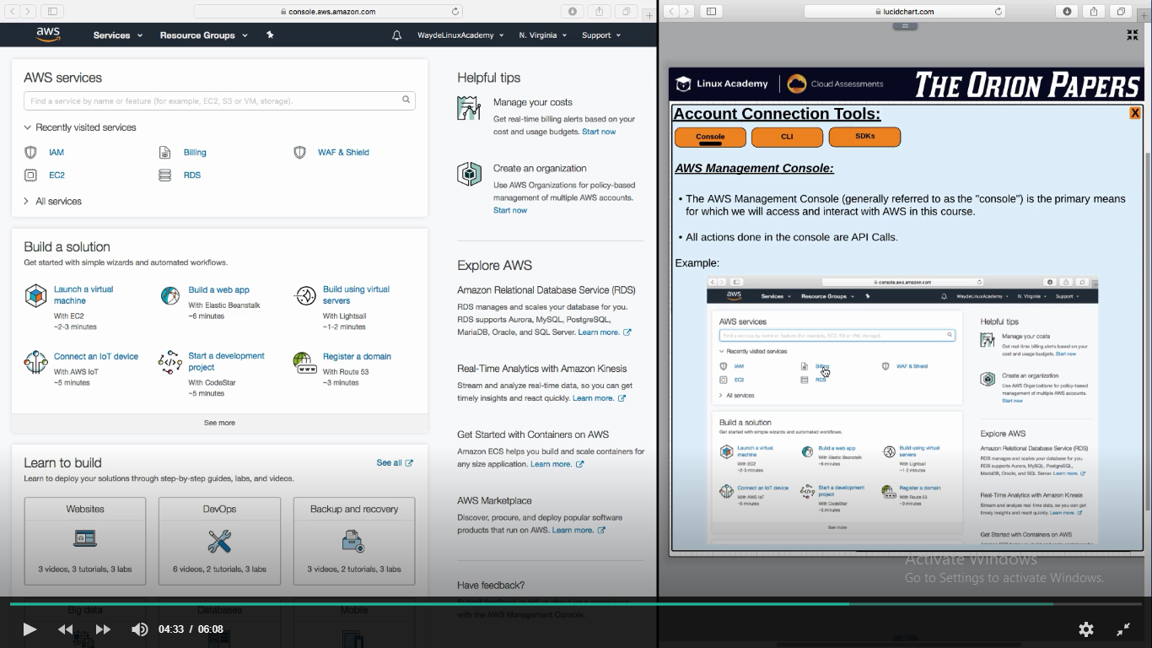

1. AWS Command Line Interface (CLI):
   1. We use it for Automated script
      1. Eg: To run a script to get the status of a instance as show below

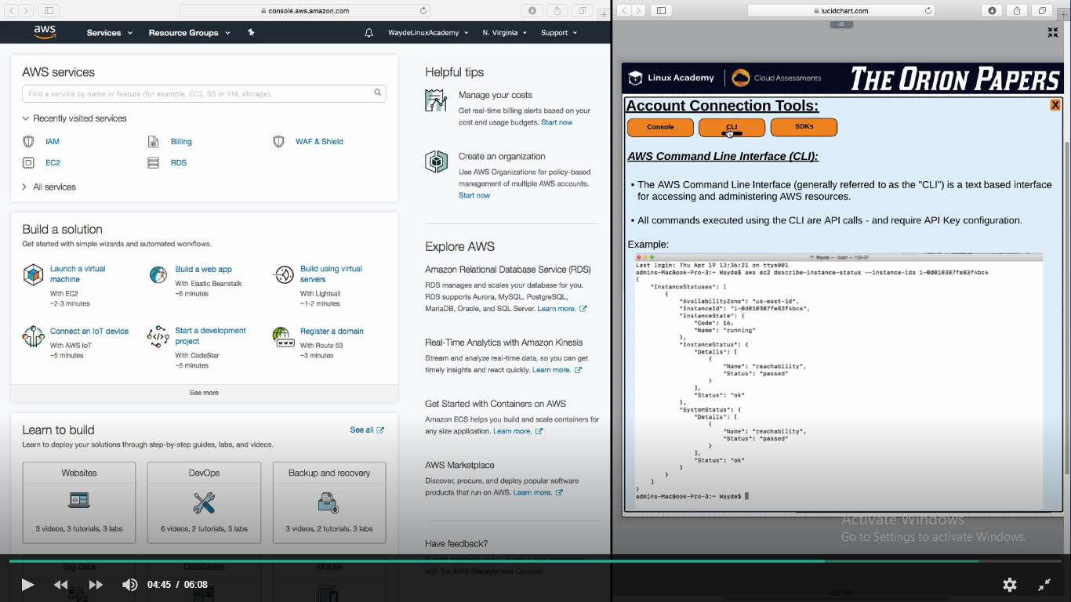

1. SDK
   1. Used by Developers to develop an application which interacts with AWS
   2. Below means make API call to connect with AWS Console

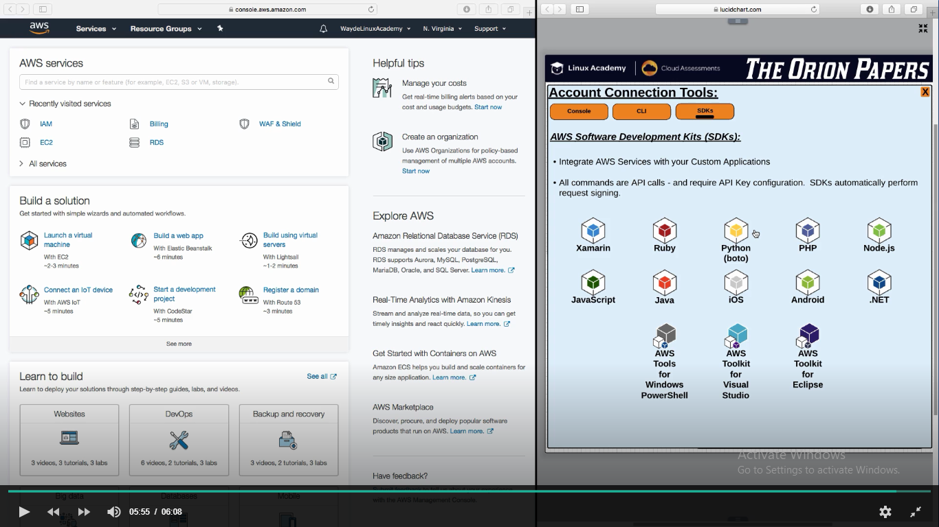

**ACCOUNT** **AND SERVICE LAYER SETUP:**

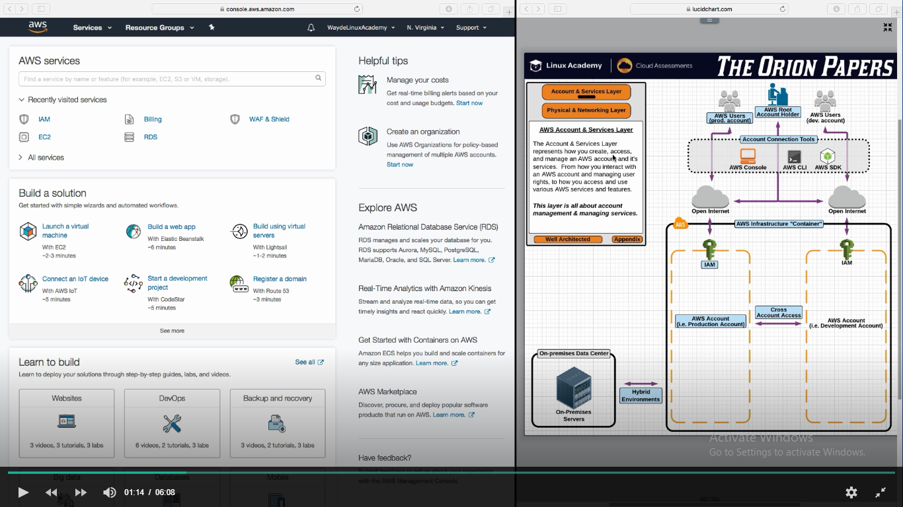

Every user must be provided access to access API and perform an operation.

Initially when we create an account in AWS we created with email address and it have full privilege to all its services. This user is the root user.

We have to use IAM (Identity and Access Manager) to restrict user and decide what operation/service that user is going to do. An organization will have multiple AWS accounts. As shown in above picture “Production Account” shall not be give access for all users.

**PROD Account configurations:**

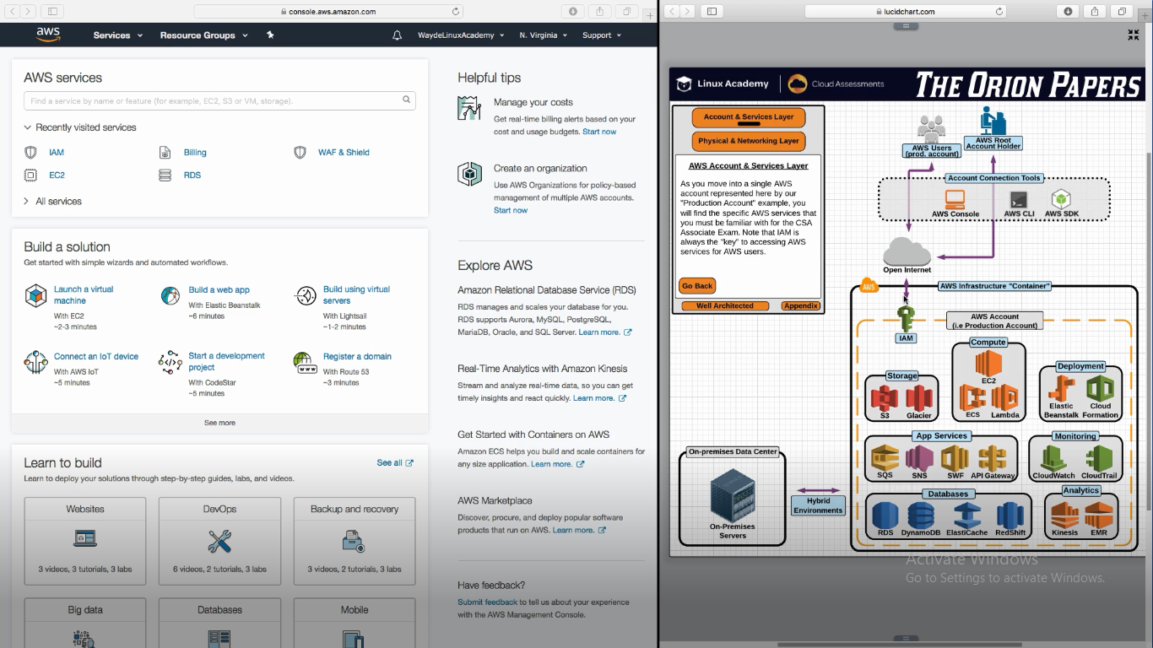

Users access AWS api via internet. It is possible to use private connection – DIRECT Connect

1. **Physical and Network Layer:**

**DataCenters:**

AWS Regions

AWS Edge Location

Regional Edge Cache

This speaks about where the AWS servers are located and how we access them

Below are the active AWS regions

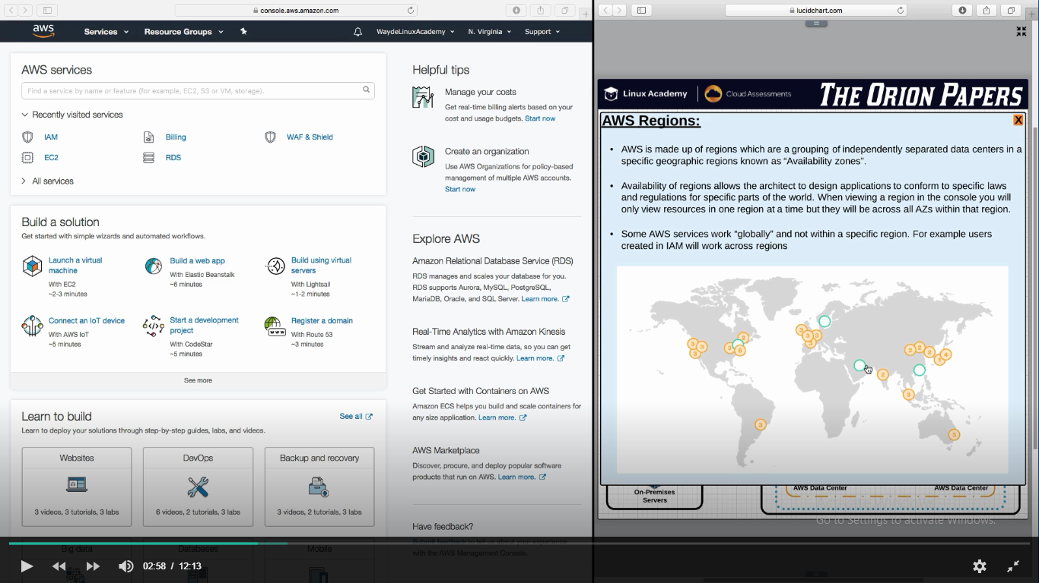

**Make your application available in HA**

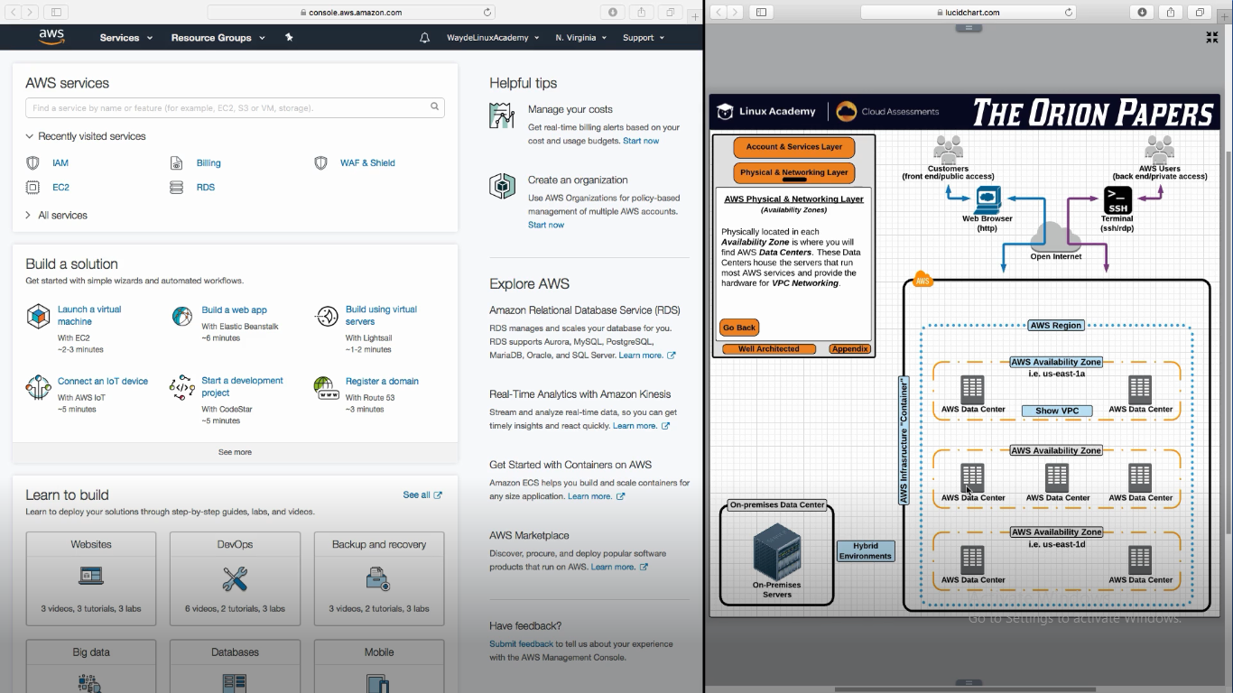

**AWS Edge Location**

In addition to region, AWS have another set of data Centers called as AWS Edge Location. These are not affiliated to regions. It runs two services

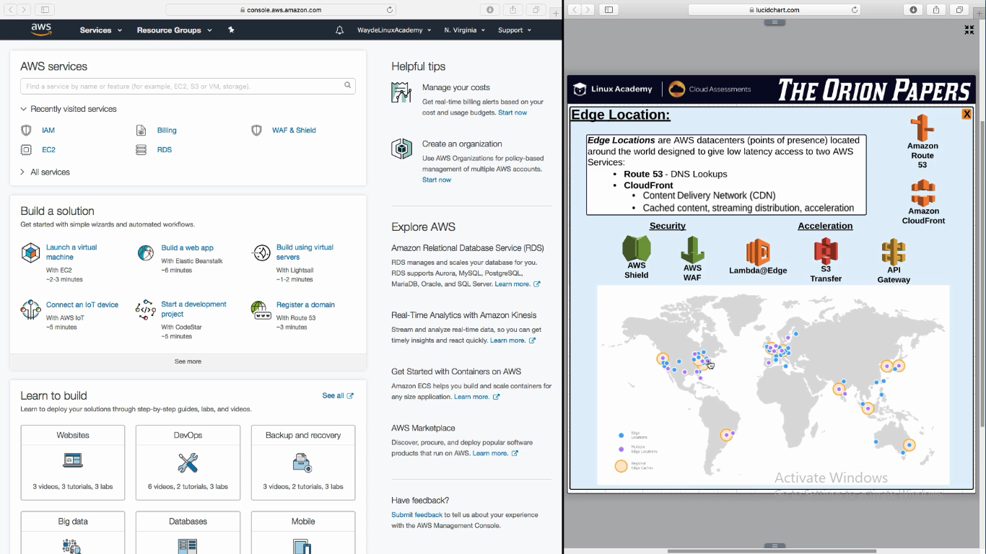

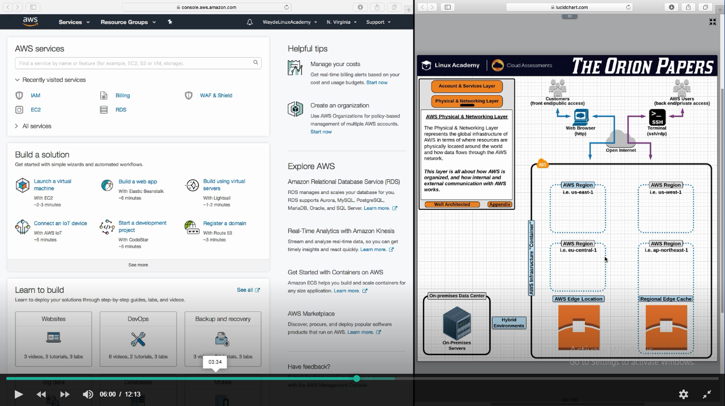

1. **Route 53 :** DNS lookup (if we type aws website with uname and password it will realize on which ip to go and hit in that target server)
2. **CloudFront:**

Content Delivery Network (CDN) – Frequently accessed data

* 1. Reduce latency, streaming, accelerates performance
  2. IT accelerate all AWS Services

* 1. Security and Acceleration
     1. AWS Shield: Block the attackers why try to attact the application
     2. AWS WAF : Web Application Firewall – Block application layer attack
     3. Lamda Ser vice : If we put the code in it, it will automatically execute it
     4. S3 Transfer
     5. API Gateway

**Regional Edge Cache:**

This is a feature of Cloud Front. IF edge location data is full, it comes to regional edge cache.

